Introduction
Every enterprise is powered by data. We take information in, analyse it, manipulate it and create more data as output. Every application creates data, whether it is log messages, metrics, user activity, outgoing messages, or something else.
Every byte of data has a story to tell, something of importance that will inform the next thing to be done. In order to know what that is, we need to get the data from where it is created to where it can be analysed. The faster we can do this the more agile and responsive our organisations will be.
The less effort we put on moving the generated data from the source where it is generated to the place where it is analysed, the more we can focus on the core business logic.
Even we get to see this on our daily basis. Bases on our interaction on the E-Commerce sites, the items we seek are often shown as recommendation at a later point in time.
Publish / Subscribe Messaging
Before discussing the specifics of Apache Kafka, it is important for us to understand the concept of publish/subscribe messaging and why it is a critical component of data-driven applications.
Publish/subscribe (pub/sub) messaging is a pattern where the sender (publisher) has categorized chunks of data to be sent to the receiver (subscriber) only when the receiver is subscribed to the publisher.
Publish/subscribe (pub/sub) systems often have a broker, a central point where messages are published, to facilitate this pattern.
For example, you create an application that needs to send monitoring information somewhere, so you open a direct connection from your application to an app that displays your metrics on a dashboard, and push metrics over that connection, as seen in Figure below:

A single, direct metrics publisher
Moving forward in the timeline we might have many systems which are producing some kind of matrices to other servers which are actively analysing the same. This might look like below :
Many metrics publishers, using direct connections
Now in the situation above the producers share a direct connection with the receivers with a possible m x n number of connections. Where m – number of producers, n - number of consumers.
Now at this point based on the picture above the architecture seems pretty complex. It will be nice to have an intermediate system to which events can be produced and from which events can be queried on demand. Such desire gives rise to an architecture as shown below :
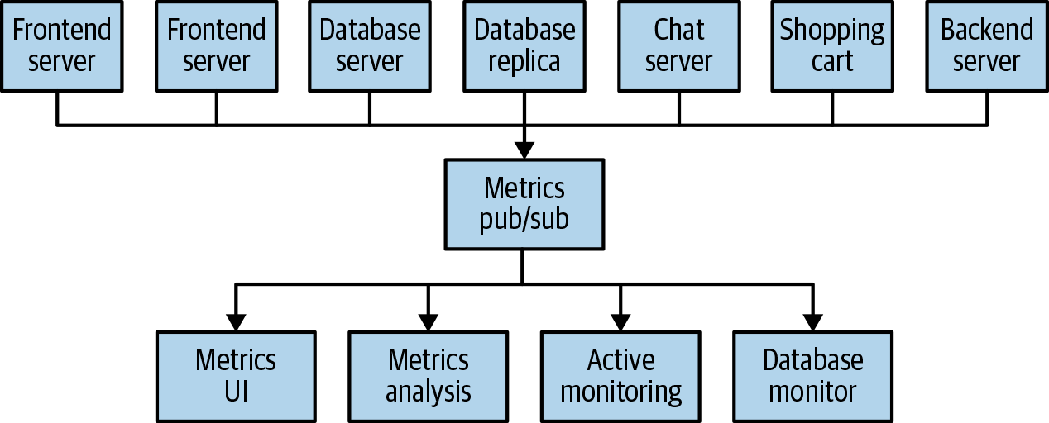
A metrics publish/subscribe system
Congratulations, we just have built a publish/subscribe messaging system!

Now, we can add more complexity to the existing publish / subscribe system. As we continue to grow in an application, we might need a separate pub / sub system for handling log messages. We might also have pub / sub system tracking some user analytics on some front end. This situation architecture will look something as shown below:

Multiple publish/subscribe systems

Now in above scenario there is a feature implementation duplication of queuing data. Also as our expectation grows we might have more pub / sub systems allowing more duplication.

What would be ideal is to have a single centralized system which publishes generic type data which will grow as your business grows.

Apache Kafka To The Rescue
Apache Kafka was developed as a publish/subscribe messaging system designed to solve this problem.

It is often described as a “distributed commit log” or more recently as a “distributing streaming platform.” A
filesystem or database commit log is designed to provide a durable record of all transactions so that they can be replayed to consistently build the state of a system. Similarly, data within Kafka is stored durably, in order, and can be read deterministically.

In addition, the data can be distributed within the system to provide additional protections against failures like retrieving data from the cache on an application event failure, as well as significant opportunities for scaling performance.

Messages & Batches:

The unit of data within Kafka is called a message. If you are approaching Kafka from a database background, you can think of this as similar to a row or a record.

A message is simply an array of bytes as far as Kafka is concerned, so the data contained within it does not have a specific format or meaning to Kafka.

A message can have an optional piece of metadata, which is referred to as a key. The key is also a byte array and, as with the message, has no specific meaning to Kafka. Keys are used when messages are to be written to partitions in a more controlled manner.

For efficiency, messages are written into Kafka in batches. A batch is just a collection of messages, all of which are being produced to the same topic and partition.

An individual round trip across the network for each message would result in excessive overhead, and collecting messages together into a batch reduces this. Of course there is a trade off between the latency and throughput here. The larger the batch more messages can be handled per amount of time but longer it takes for individual message to propagate.

Batches are also typically compressed, providing more efficient data transfer and storage.

Both keys and batches are discussed later.

Schemas

Usually, messages are byte arrays to Kafka itself but it is advised to impose some kind of additional structure or schema to the message content so that it can be easily understood.

There are many options available for message schema, depending on your application’s individual needs. Simplistic systems, such as JavaScript Object Notation (JSON) and Extensible Markup Language (XML), are easy to use and human readable.

However, they lack features such as robust type handling and compatibility between schema versions. Many Kafka developers favor the use of Apache Avro, which is a serialization framework originally developed for Hadoop.
A consistent data format is very important in Kafka.

Topics and Partitions

Messages in Kafka are categorized into topics. The closest analogies for a topic are a database table or a folder in a filesystem.

Topics are additionally broken down into a number of partitions to which messages are written in append-only fashion. While messages are read they will be read from beginning to end.

Message ordering can’t be guaranteed in side an entire topic but the same can be expected within a single partition.

The above picture shows a topic with four partitions, with writes being appended to the end of each one.

Partitions are also the way that Kafka provides redundancy and scalability. Each partition can be hosted on a different server, which means that a single topic can be scaled horizontally across multiple servers to provide performance far beyond the ability of a single server.

Additionally, partitions can be replicated, such that different servers will store a copy of the same partition in case one server fails.

The term stream is often used when discussing data within systems like Kafka. Most often, a stream is considered to be a single topic of data, regardless of the number of partitions. This represents a single stream of data moving from the producers to the consumers.

